Name - Aparna Bharti

Batch - Data Engineering batch-1

**TOPIC - SQL JOINS**

SQL_JOINS.DOCS

**Equi join**

EQUI JOIN creates a JOIN for equality or matching column(s) values of the relative tables. EQUI JOIN also creates JOIN by using JOIN with ON and then providing the names of the columns with their relative tables to check equality using equal sign (=).

**Syntax**

SELECT column_list

FROM table1, table2....

WHERE table1.column_name =

table2.column_name;

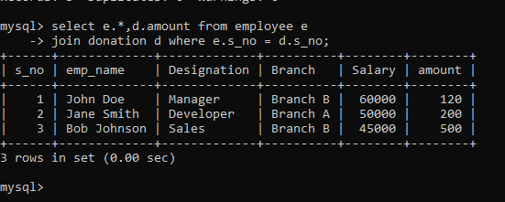

**Non-Equi join**

NON EQUI JOIN performs a JOIN using comparison operator other than equal(=) sign like >, <, >=, <= with conditions.

**Syntax**

SELECT *

FROM table_name1, table_name2

WHERE table_name1.column [> | < | >= | <= ] table_name2.column;

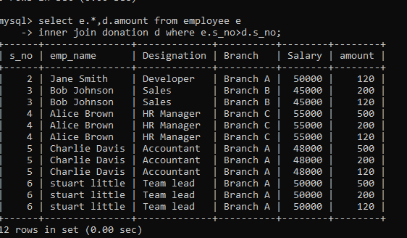

SQL_JOIN.DOCS

**Inner Join**

The INNER JOIN keyword selects records that have matching values in both tables.

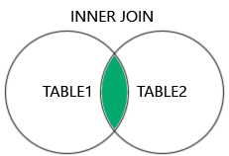

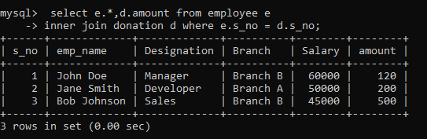

**Left Join**

The LEFT JOIN keyword returns all records from the left table (table1), and the matching records from the right table (table2). The result is 0 records from the right side, if there is no match.

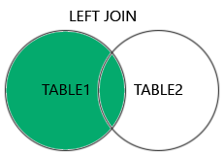

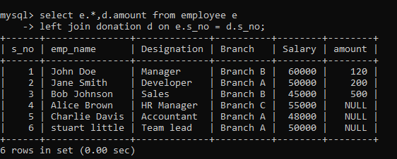

**Right Join**

The RIGHT JOIN keyword returns all records from the right table (table2), and the matching records from the left table (table1). The result is 0 records from the left side, if there is no match.

Syntax

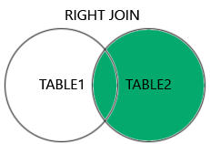

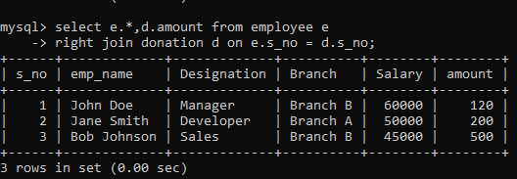

**Full Join**

The FULL OUTER JOIN keyword returns all records when there is a match in left (table1) or right (table2) table records.

FULL OUTER JOIN and FULL JOIN are the same.

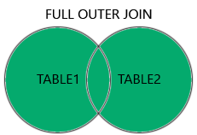



**Self Join**

A self join is a regular join, but the table is joined with itself.

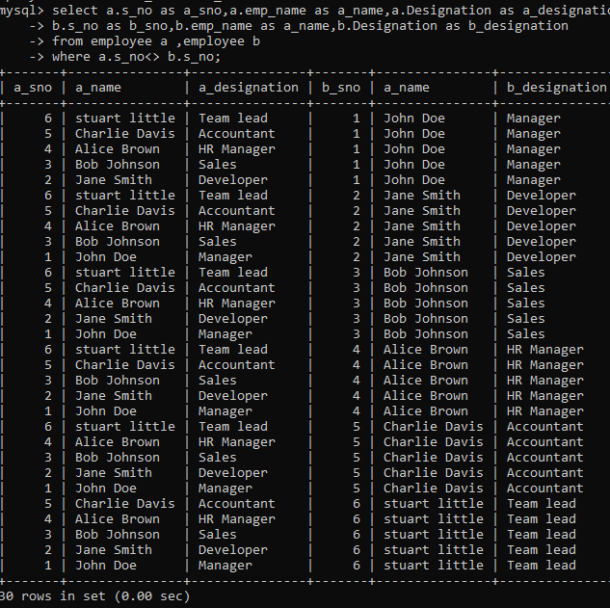

**Natural join**

Natural join is an SQL join operation that creates a join on the base of the common columns in the tables. To perform natural join there must be one common attribute(Column) between two tables. Natural join will retrieve from multiple relations

### **Features of Natural Join**

Here, we will discuss the features of natural join.

1. It will perform the Cartesian product.
2. It finds consistent tuples and deletes inconsistent tuples.
3. Then it deletes the duplicate attributes.

**Syntax**

SELECT *

FROM TABLE1

NATURAL JOIN TABLE2;

